**AIRLINE RESERVATION SYSTEM**

**Aim:**

To draw UML diagram for Airline Reservation system using umbrello tool.

**USE CASE DIAGRAM**

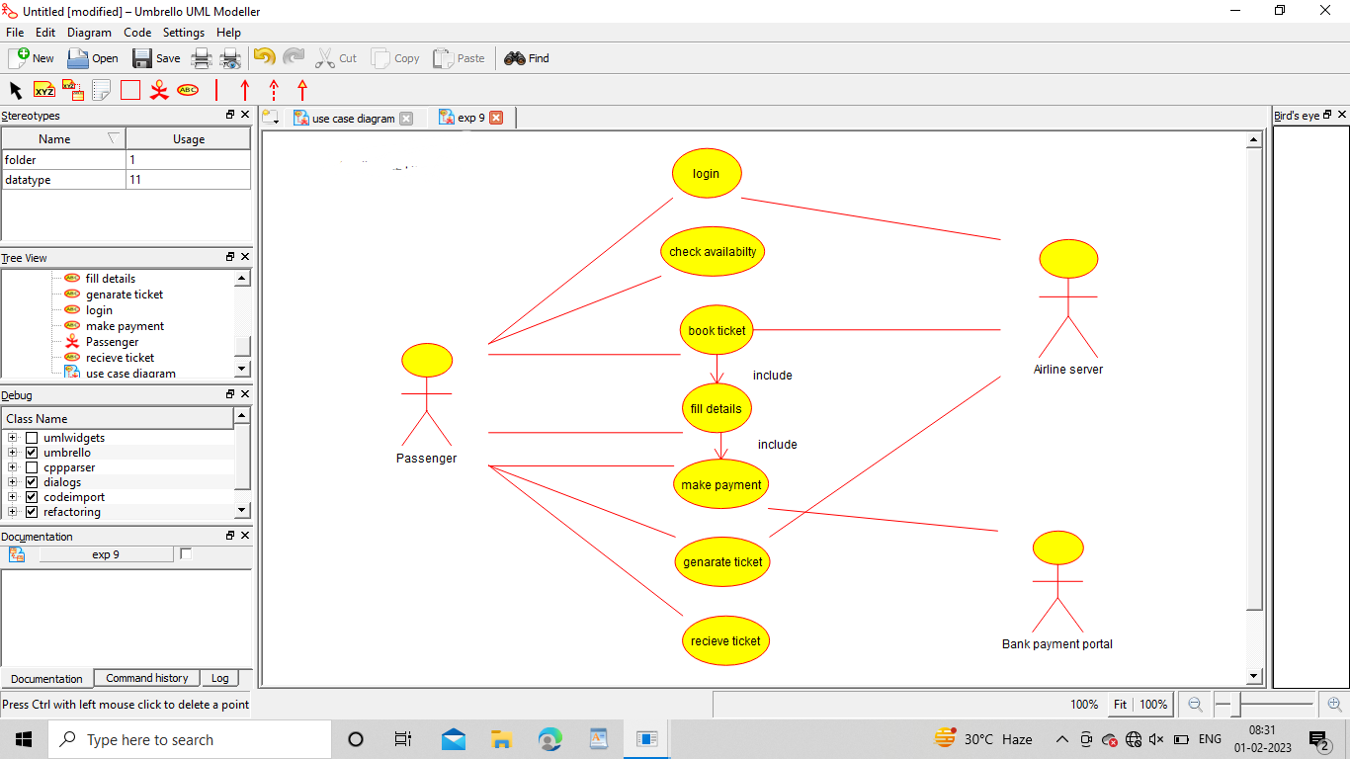

**CLASS DIAGRAM**

